**Docker Task -3**

Create a custom docker image for nginx and deploy it using docker compose, where the volume bind mount should be at /var/opt/nginx location. Push the created custom docker image to your docker-hub.

* **Create a Custom Nginx Docker file and Build the Docker Image**

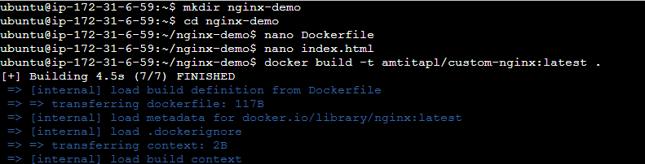

**Dockerfile**

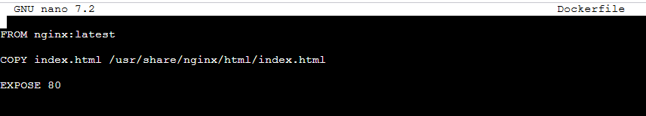

**Index.html**

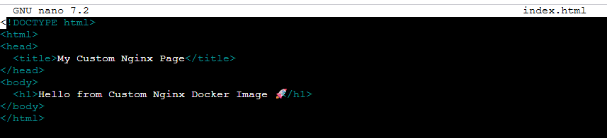

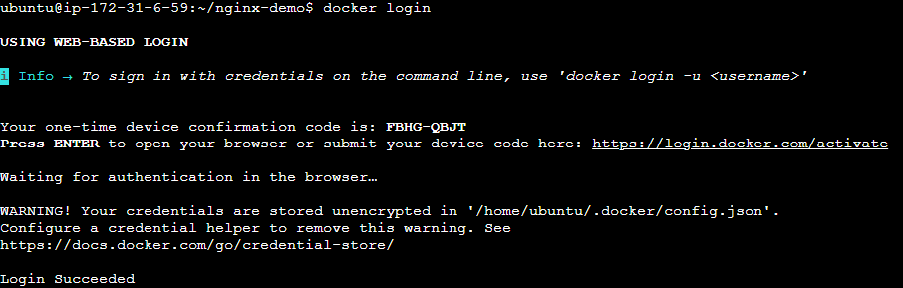

**Docker Compose**

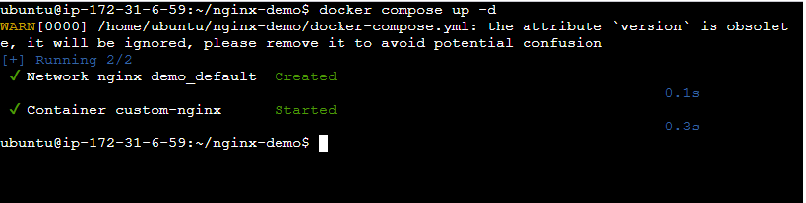

**Push Image in Docker Hub**

